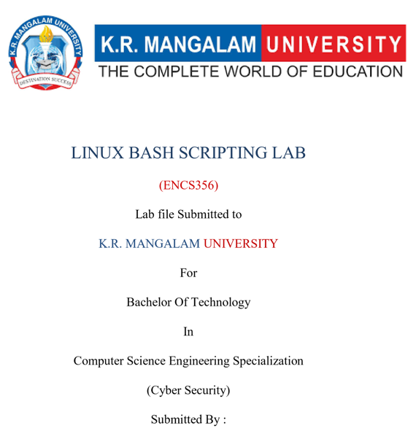
Rohan Singh (2301410032)
Faculty: Dr. Rajesh Kumar



Experiment No. 1
Exploring Linux System Commands, Run Levels (Targets), and Help Utilities.

Problem Statement

Efficient use of the Linux operating system requires a strong understanding of basic system commands, system states, and built-in help mechanisms. Unlike graphical operating systems, Linux relies heavily on command-line utilities for system interaction, administration, and automation.
The problem is to explore and practice essential Linux system commands, understand system run levels / targets, and effectively use Linux help utilities such as man, --help, and auto- completion to access command documentation and usage information.

Aim
To study and execute basic Linux system commands, understand Linux run levels (systemd targets), and use Linux help utilities such as _{man}, _{--help}, and tab auto-completion.

Theory
Linux Command Line Interface (CLI)
The Linux Command Line Interface allows users to interact with the operating system by typing commands. It provides better control, flexibility, and efficiency compared to graphical interfaces, especially for system administration and automation.
System Run Levels / Targets
➢ Modern Linux systems use systemd, where traditional run levels are replaced by targets.
Common systemd targets:
- graphical.target – Multi-user mode with GUI
- multi-user.target – Multi-user mode without GUI
- _{rescue.target} – Single-user rescue mode
- poweroff.target – Shutdown system
- reboot.target – Reboot system
Linux Help Utilities
Linux provides built-in help tools for learning commands:
- _{man} – Displays complete manual pages • _{--help} – Shows brief command usage
- Tab auto-completion – Completes commands and file names automatically

Commands Used
Commands | Description
pwd | Display present working directory
ls | List files and directories
cd | Change directory
whoami | Display current user
date | Show system date and time
uptime | Show system running time
man | Display manual pages
--help | Display help for a command
systemctl | Manage system services and targets
runlevel | Display previous and current run level
clear | Clear terminal screen

Procedure / Steps
Step 1: Login:
Log in to the Linux virtual machine and open the Terminal.
Step 2: Execute Basic Linux Commands in the Terminal.
Commands:
- _{pwd} shows current directory
- _{ls} lists files
- _{whoami} displays logged-in user
- _{date} shows system date/time
- _{uptime} shows how long system is running
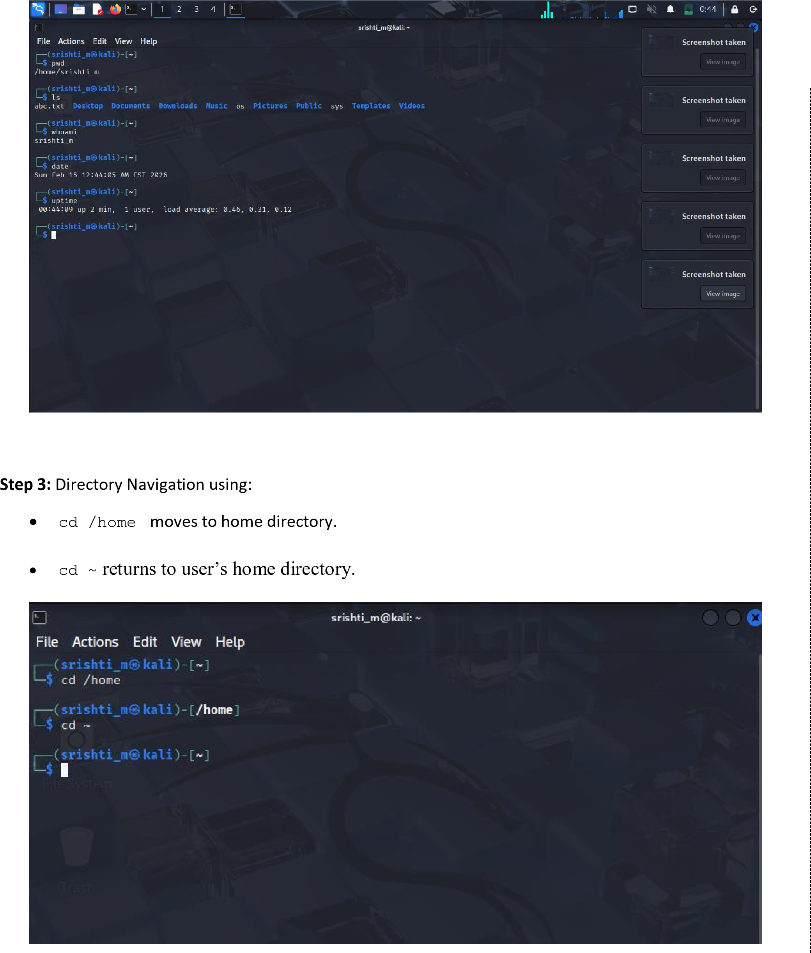

Step 4: Using Manual Pages
- man ls
- man cd
It Read command details.
➢ Press _{q} to exit the manual.
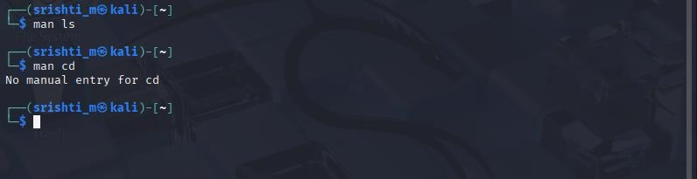

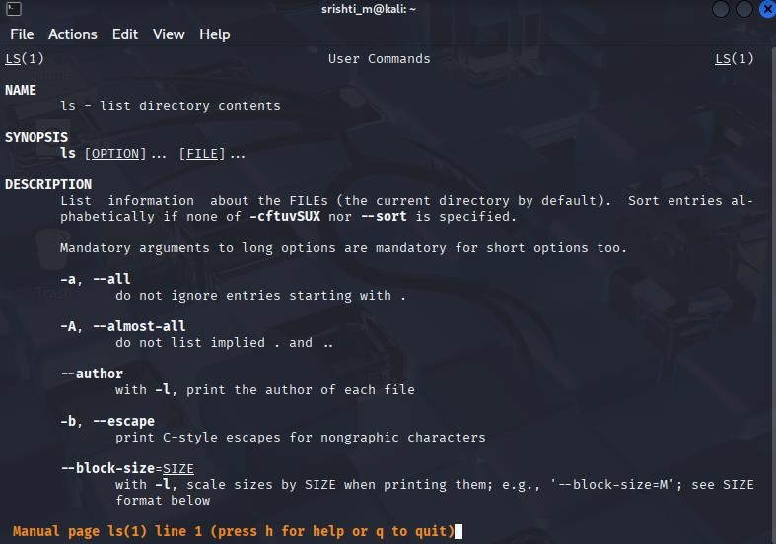
Step 5: Using Help Option:
- ls –help
- systemctl –help
This displays short usage instructions and optio
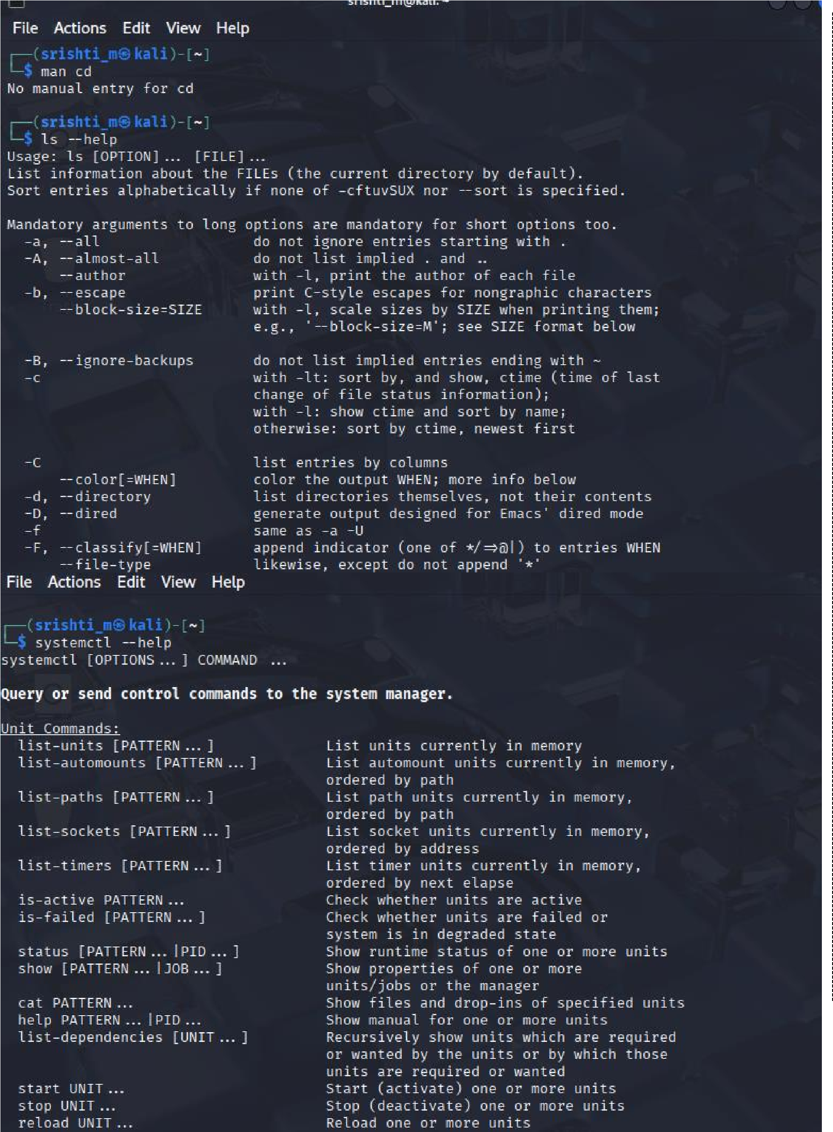

Step 6: Check System Run Level / Target
- runlevel- “Kali Linux uses systemd, so traditional runlevel commands are deprecated and systemctl targets are used instead.”
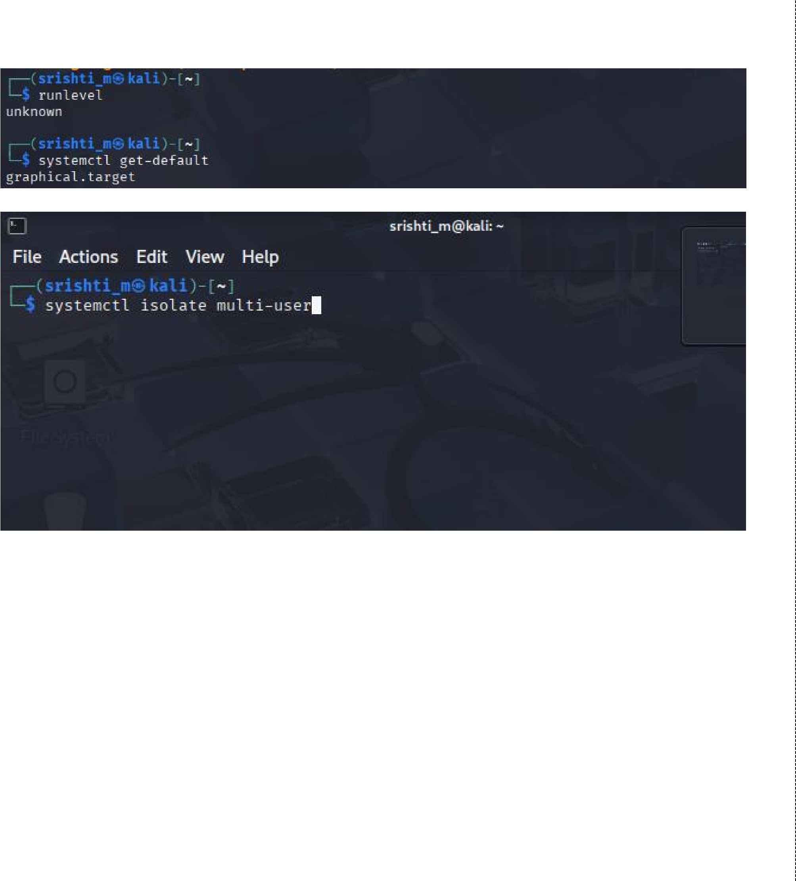• systemctl get-default shows default system target.
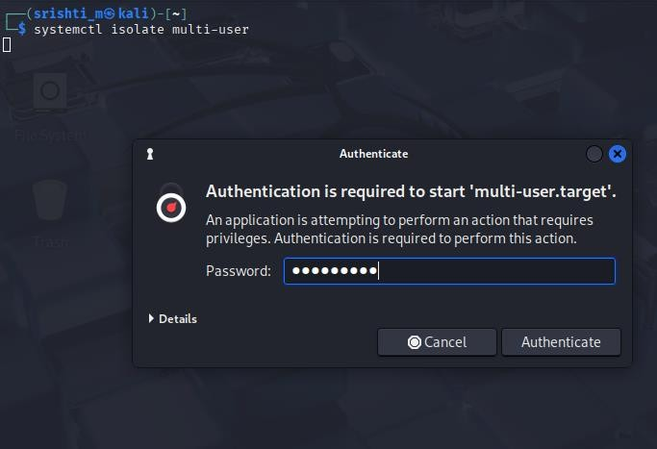
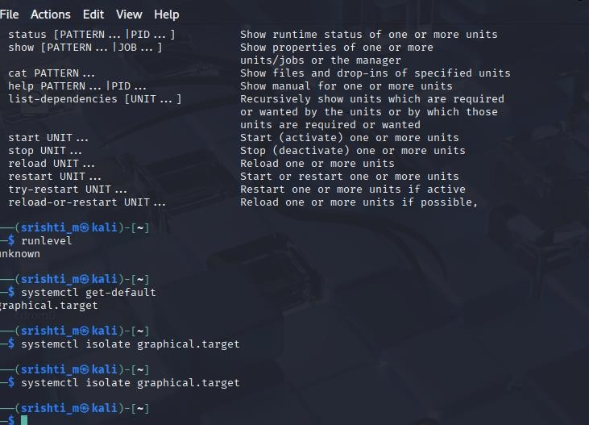
Step 7:- Practice auto-completion by typing partial command names and pressing Tab. Step 8 :- Clear the terminal screen: Clear

Outcomes
- Successful execution of basic Linux commands
- Display of manual pages and help options
- Identification of current run level/target
- Improved command-line efficiency

Result
Thus, basic Linux system commands, system run levels, and help utilities were successfully explored. The student gained practical understanding of Linux command-line interaction and Linux documentation tools.

Experiment No. 2
Title
File and Directory Management and File Permissions in Linux

Aim
To study and practice Linux commands for file and directory management, understand Linux file and directory permissions, and create and edit files using text editors such as _{nano} and vi.

Theory
Linux File System
Linux follows a hierarchical file system starting from the root directory /. All files and directories are arranged in a tree structure, allowing efficient organization and secure access control.
Files and Directories
- Files store data such as text, programs, or scripts.
- Directories store files and subdirectories.
File and Directory Permissions
Linux uses permissions to control access:
- Read (r) – Read file contents / list directory • Write (w) – Modify file or directory
- Execute (x) – Execute file or access directory
Permissions apply to:
- Owner
- Group
- Others
Text Editors
- nano: Simple and beginner-friendly text editor
- vi: Powerful editor with command and insert modes

Commands Used
Commands | Description
pwd | Display current directory
ls | List files and directories
ls -l | Display detailed file information
cd | Change directory
mkdir | Create directory
rmdir | Remove empty directory
touch | Create empty file
cat | Display file contents
nano | Edit files using nano editor
vi | Edit files using vi editor
chmod | Change file permissions
stat | Display file status

Procedure / Steps
Step 1: Login
➢ Log in to the Linux virtual machine and open the Terminal.
Step 2: Display the Current Directory using pwd command.

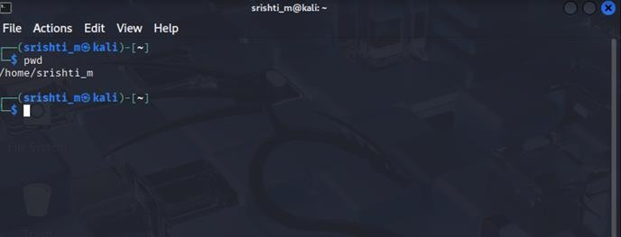
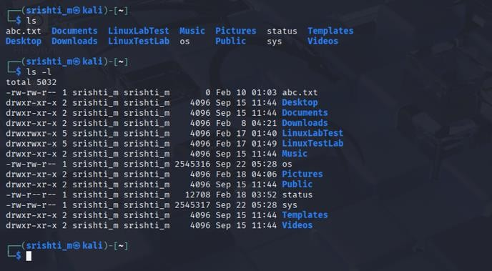
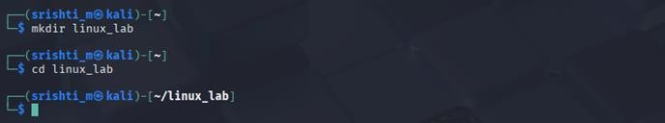
cd linux_lab

Step 3: List Files and Directories using:

•

ls

•

ls
-
l

Step 4:
Create a New Directory

mkdir

linux_lab

➢

linux_lab

directory is created and entered.

Step 5: Create Files using : -touch file1.txt file2.txt

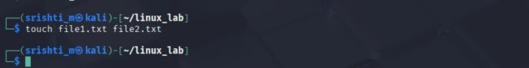
Step 6: Edit File Using : nano file1.txt
  - Type some text
  - Press Ctrl + O → Enter (save)
  - Press Ctrl + X (exit)
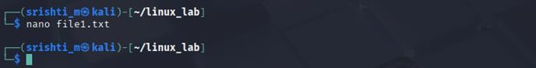
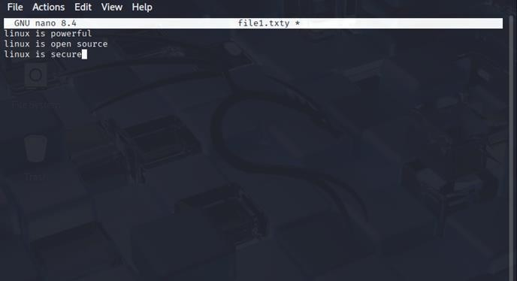

Step 7: Edit File Using : vi file2.txt
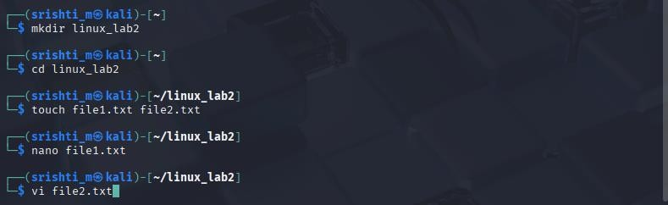

Then,
- Press i to enter insert mode
- Type text
- Press Esc
- Type::wq
- Press Enter
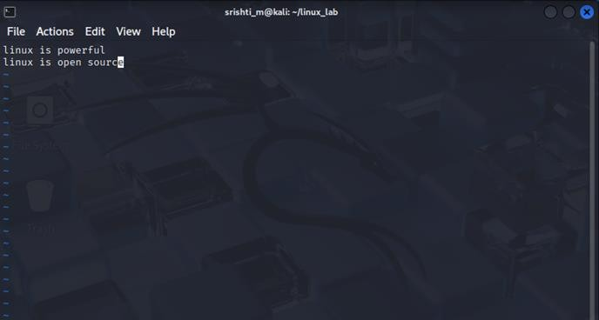

Step 8: Display File Content Using:
- cat file1.txt
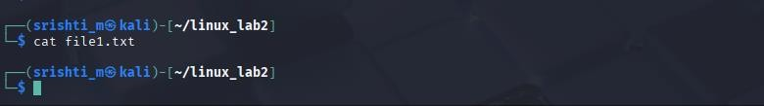

Step 9: Check File Permissions
- ls -l
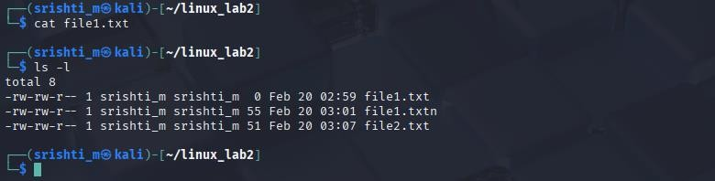
Step 10: Change File Permissions using:
- chmod 755 file1.txt
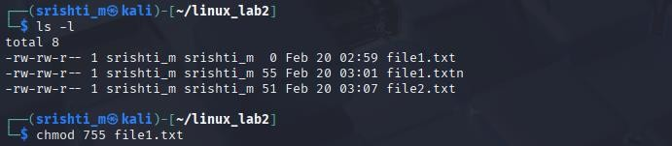

Step 11: Verify Updated Permissions Using:
- ls -l file1.txt
- we will observe permission format: _{-rw-r--r—}
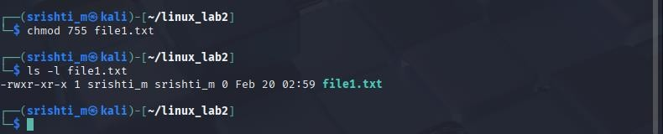

Outcomes
- Successful creation of directories and files
- Files edited using _{nano} and _{vi}
- File contents displayed using _{cat}
- File permissions viewed and modified using _{chmod}

Result
❖ Thus, file and directory management commands were successfully executed in Linux. The student learned to create, edit, and manage files and directories, understand file permissions, and use text editors such as _{nano} and _{vi}.

